10/04/2020

# Section 1: Overview of WHO Africa Region

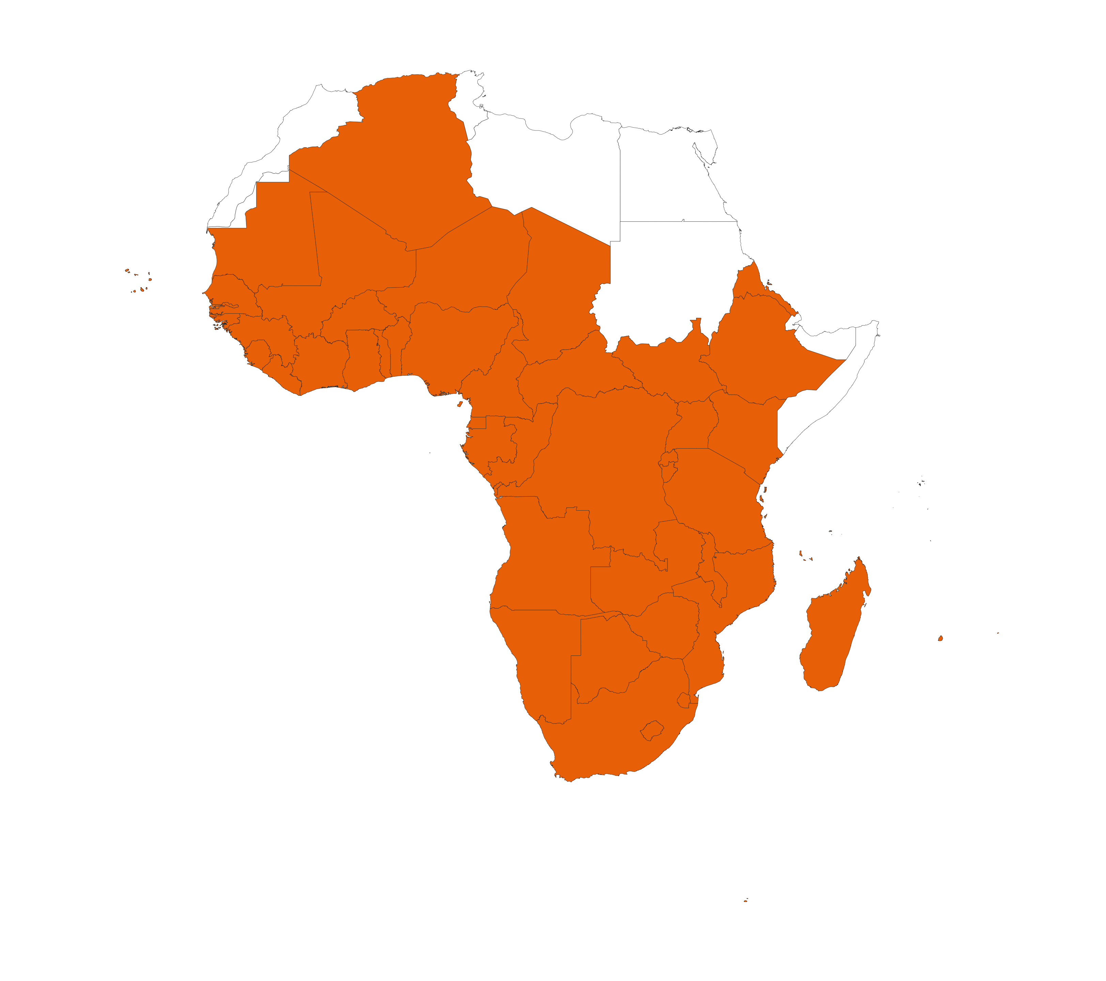

We compare the size and rate of increase of the COVID-19 epidemic across the countries included in WHO Africa Region.

The maps below summarise the in-country situations:

* Top row: cumulative reported cases (left) and deaths (right).
* Middle row: cumulative reported cases (left) and deaths (right) per 10,000 population on a log10 scale.
* Bottom row: overview of doubling time of cumulative reported cases (left) and deaths (right). Doubling times are estimated over a 7 day period up to 09/04/2020.

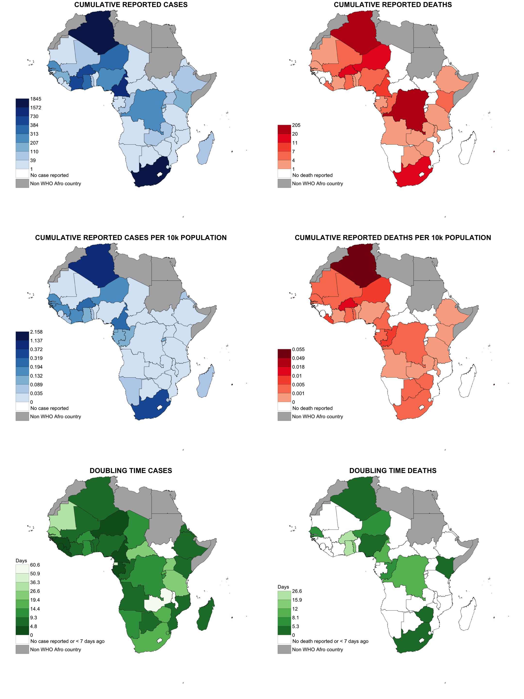

# Section 2: Individual country situations

As of 09/04/2020, each panel below shows for each country:

* Top row: cumulative reported cases (left) and deaths (right).
* Middle row: cumulative reported cases (left) and deaths (right) per 10,000 population on a log10 scale.
* Bottom row: relative increase in number of cases (left) and deaths (right) based on the doubling times (of cases and deaths respectively) estimated over a 7 day period up to 09/04/2020.

## Algeria

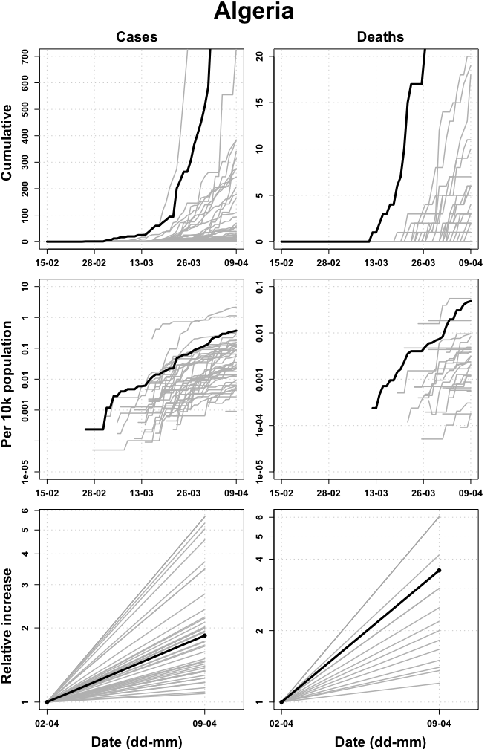

## Angola

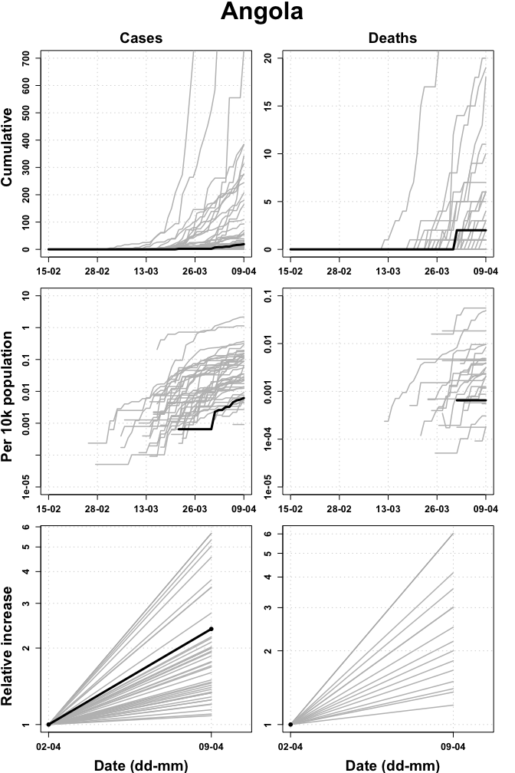

## Benin

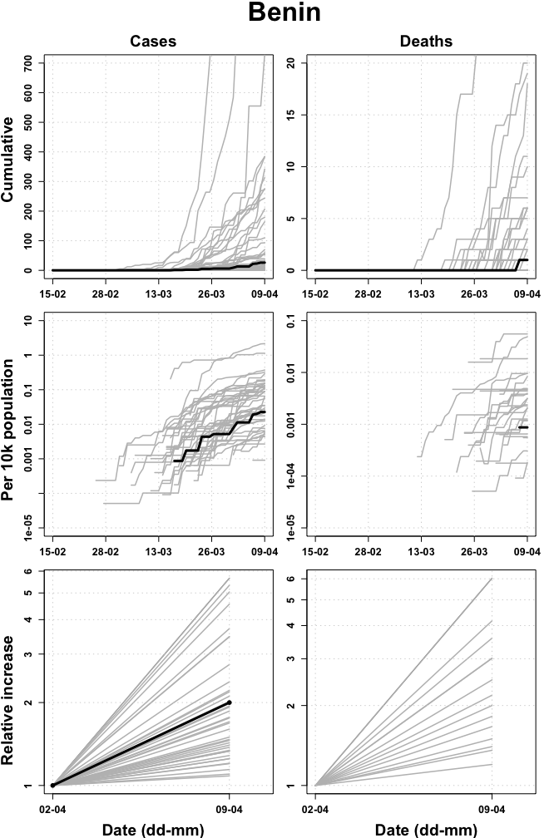

## Botswana

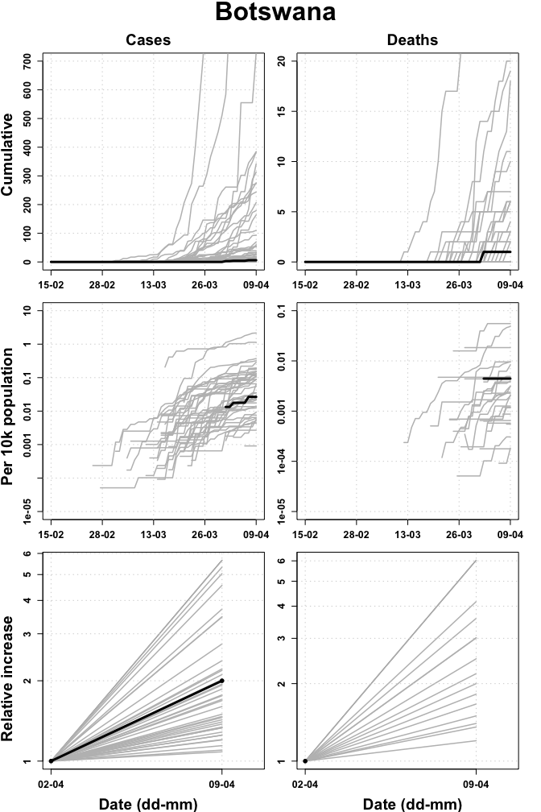

## Burkina Faso

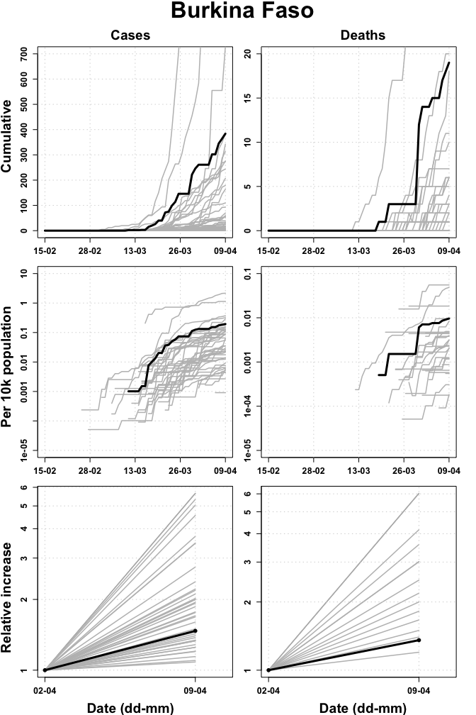

## Burundi

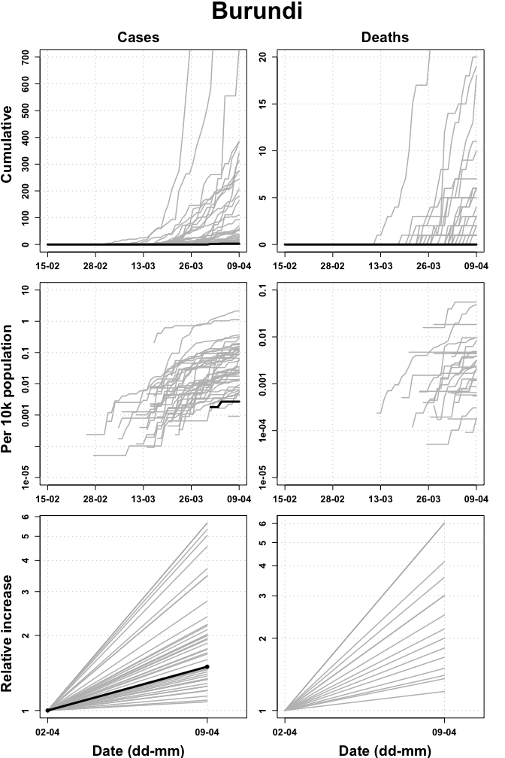

## Cabo Verde

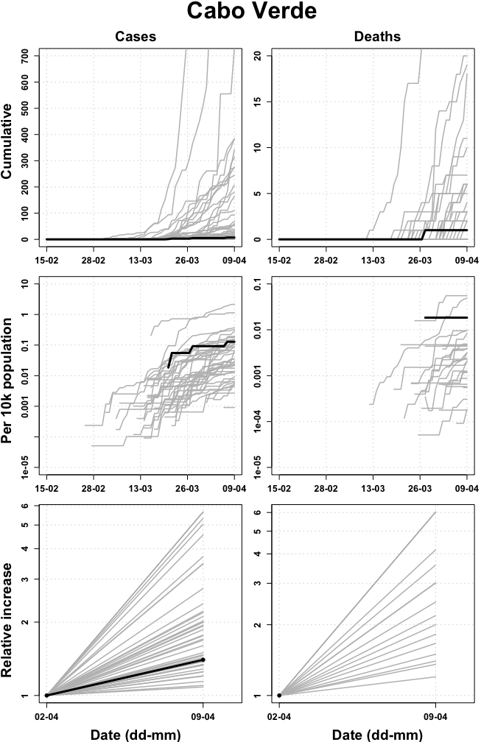

## Cameroon

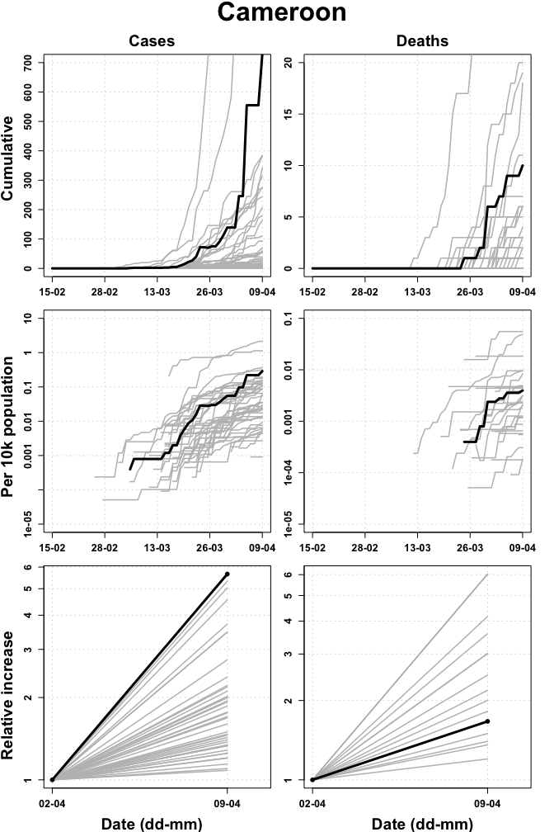

## Central African Republic

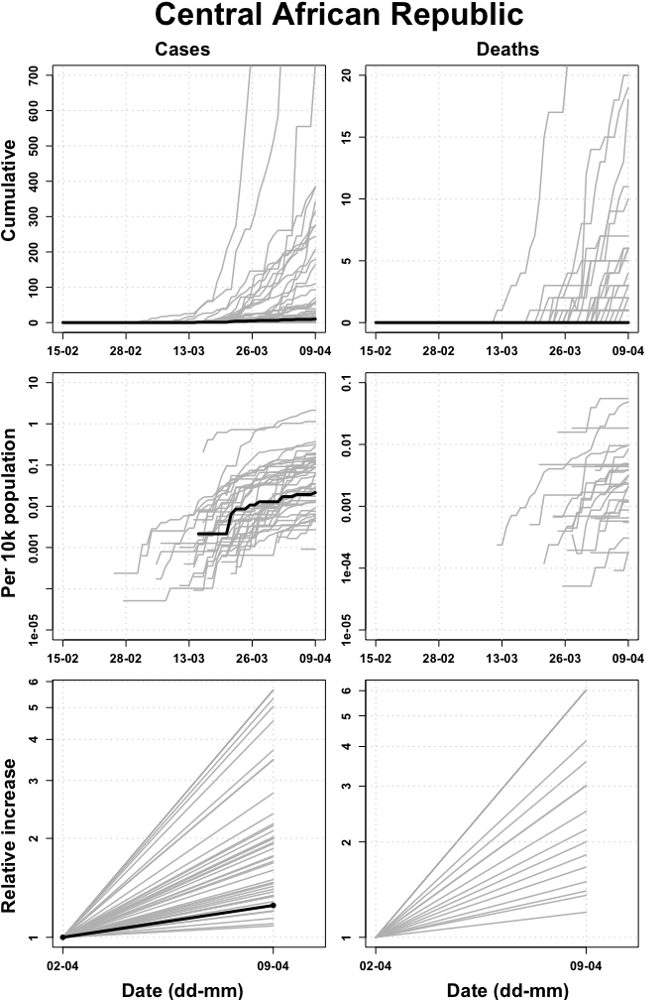

## Chad

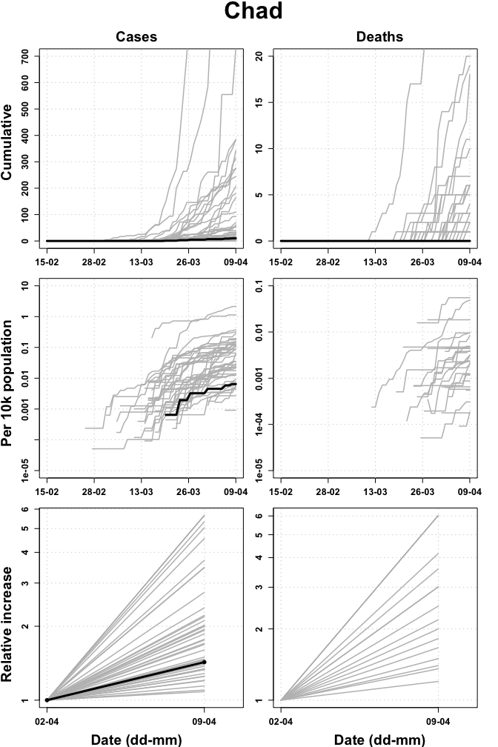

## Comoros

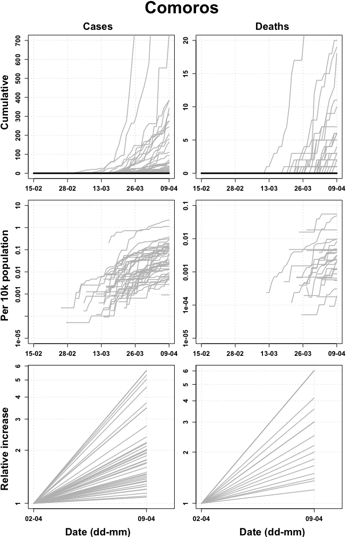

## Congo

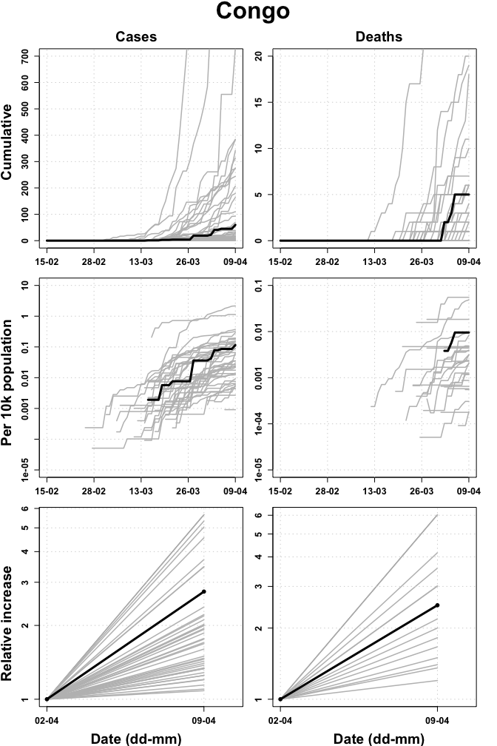

## Cote d’Ivoire

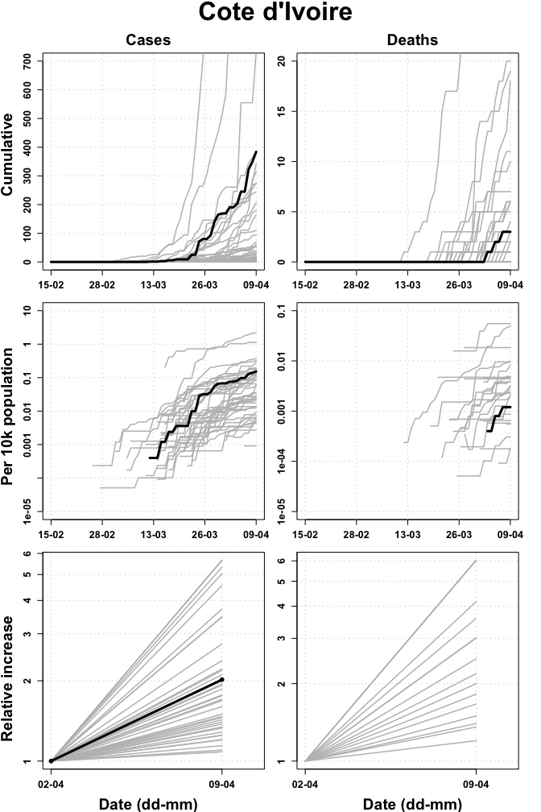

## Democratic Republic of the Congo

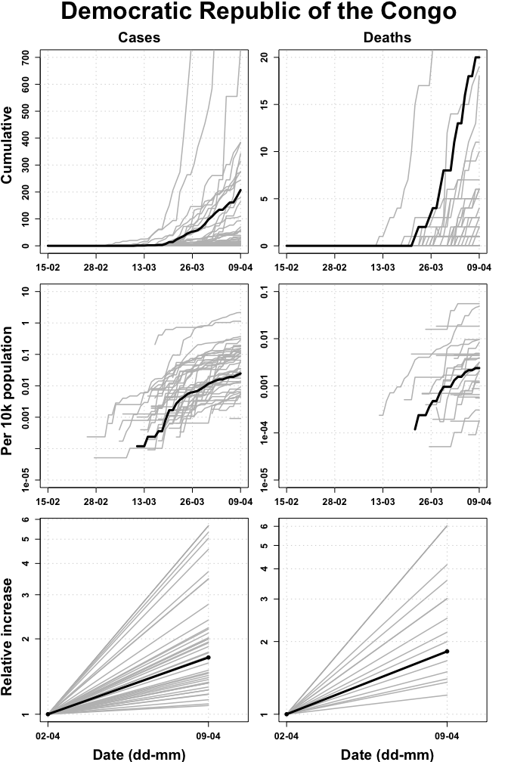

## Equatorial Guinea

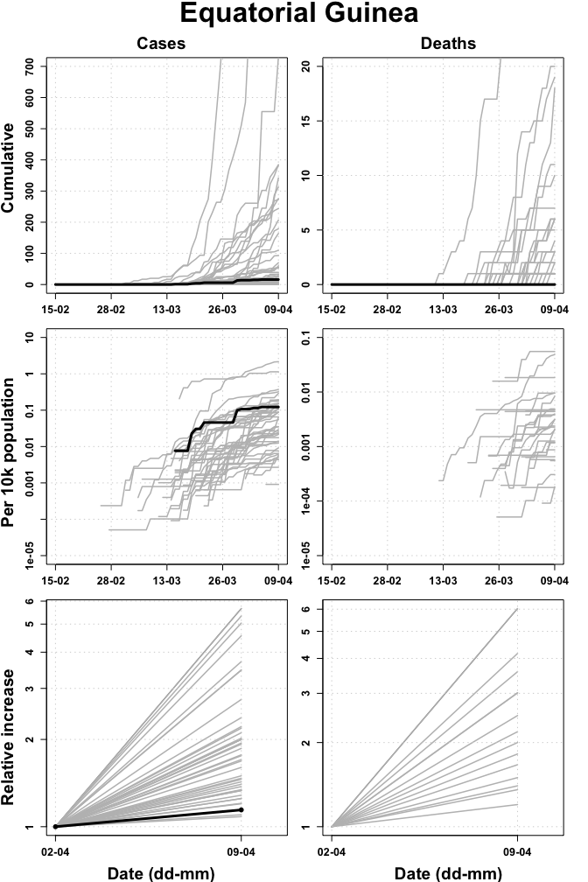

## Eritrea

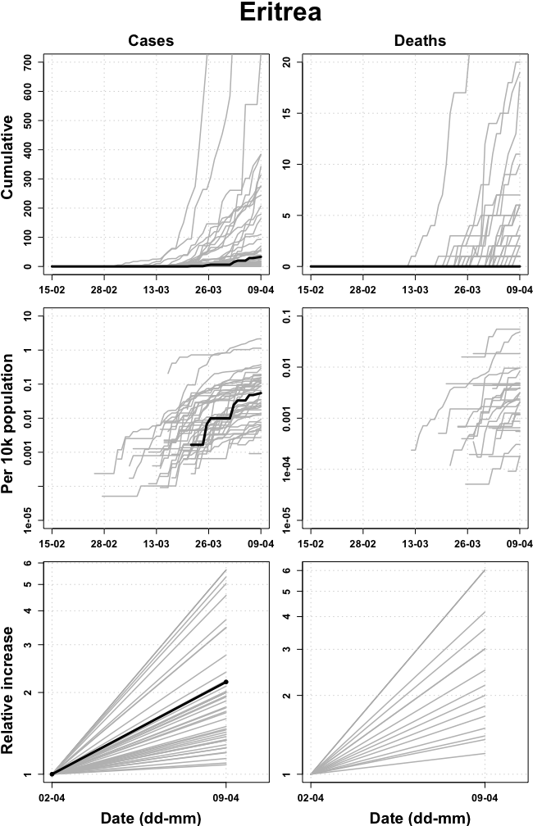

## Eswatini

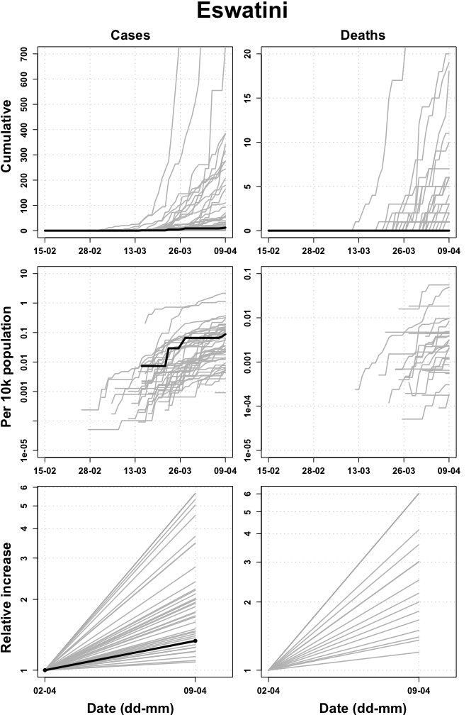

## Ethiopia

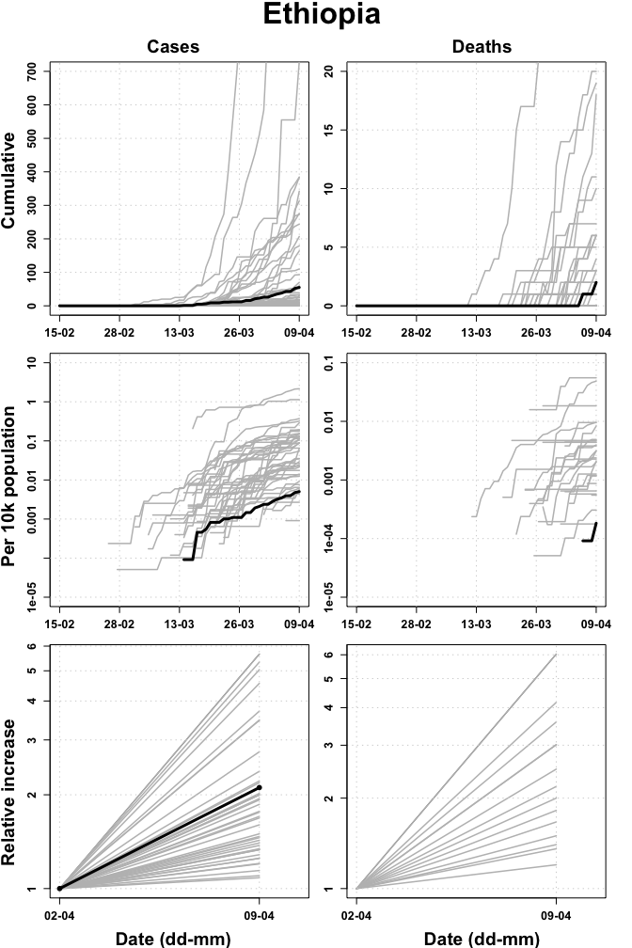

## Gabon

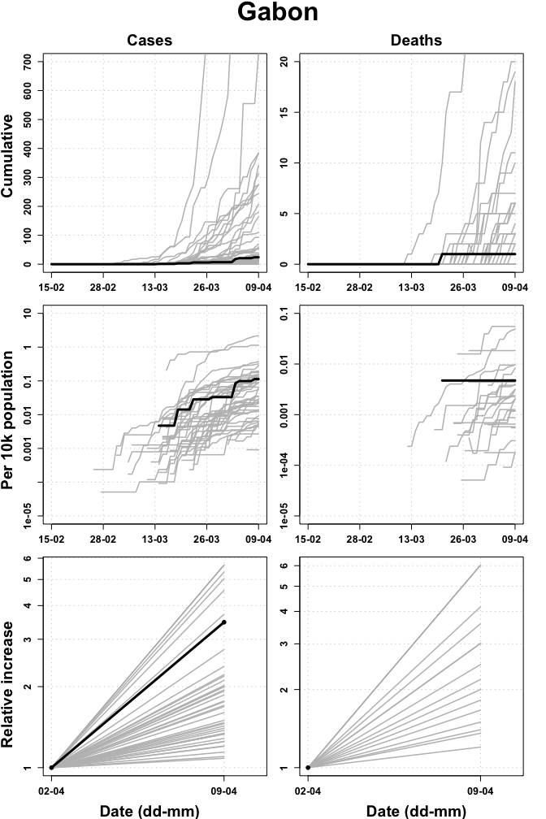

## Gambia

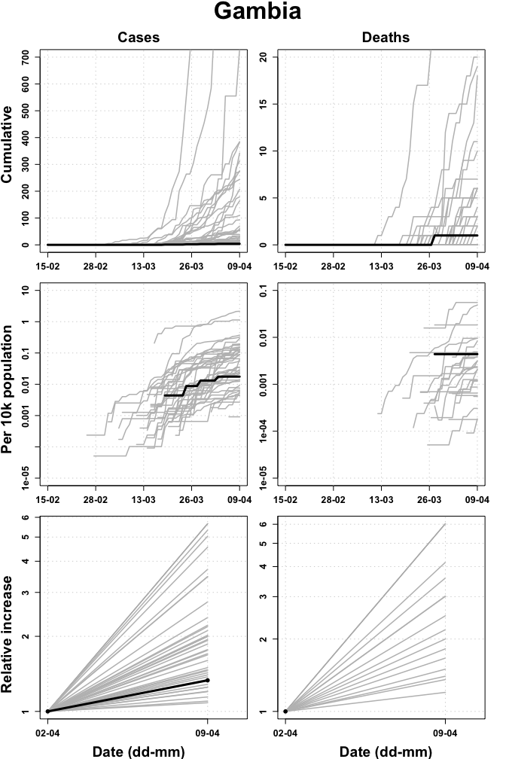

## Ghana

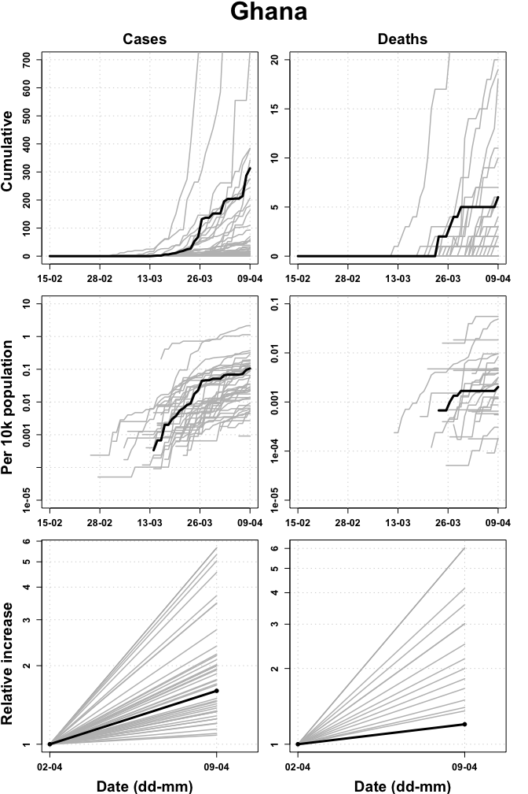

## Guinea

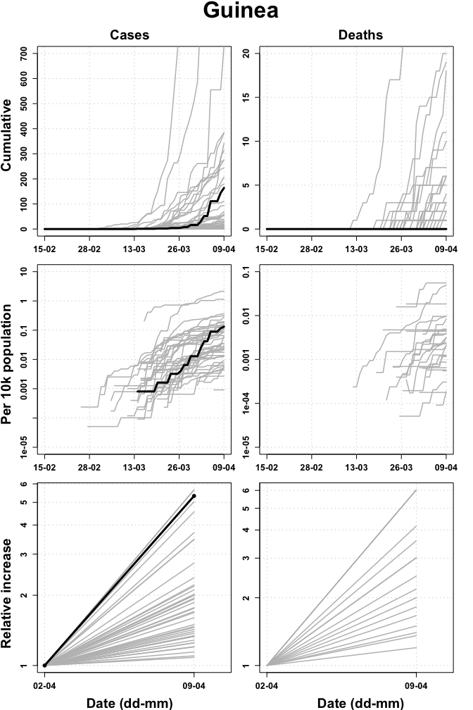

## Guinea Bissau

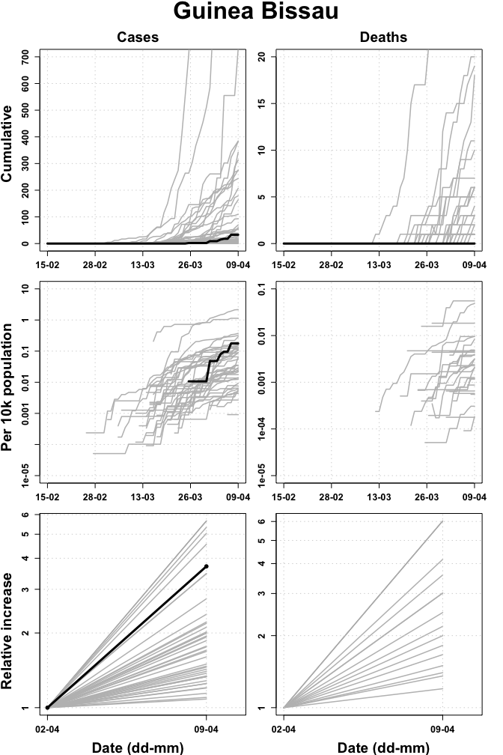

## Kenya

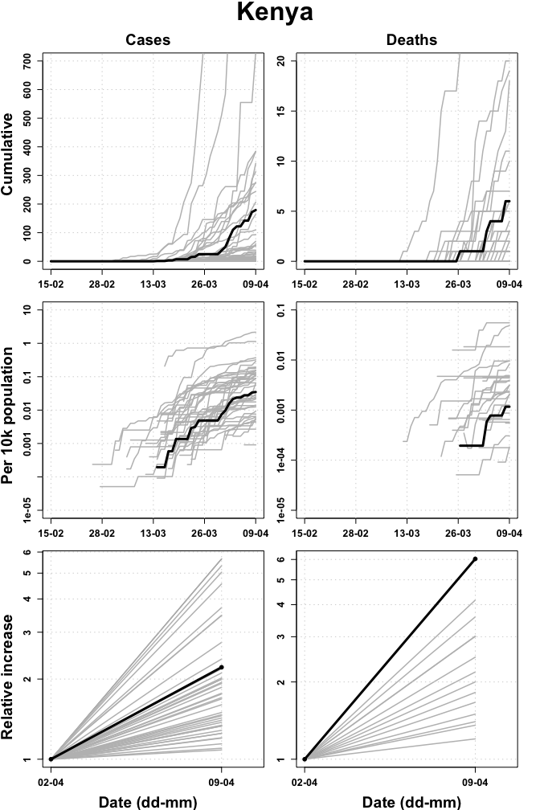

## Lesotho

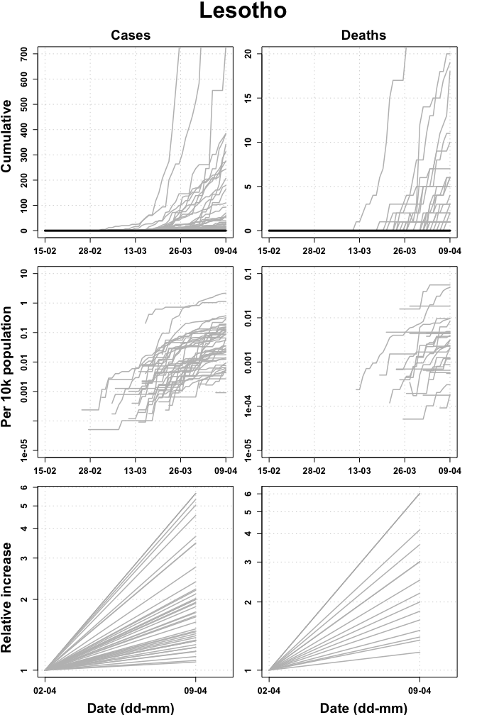

## Liberia

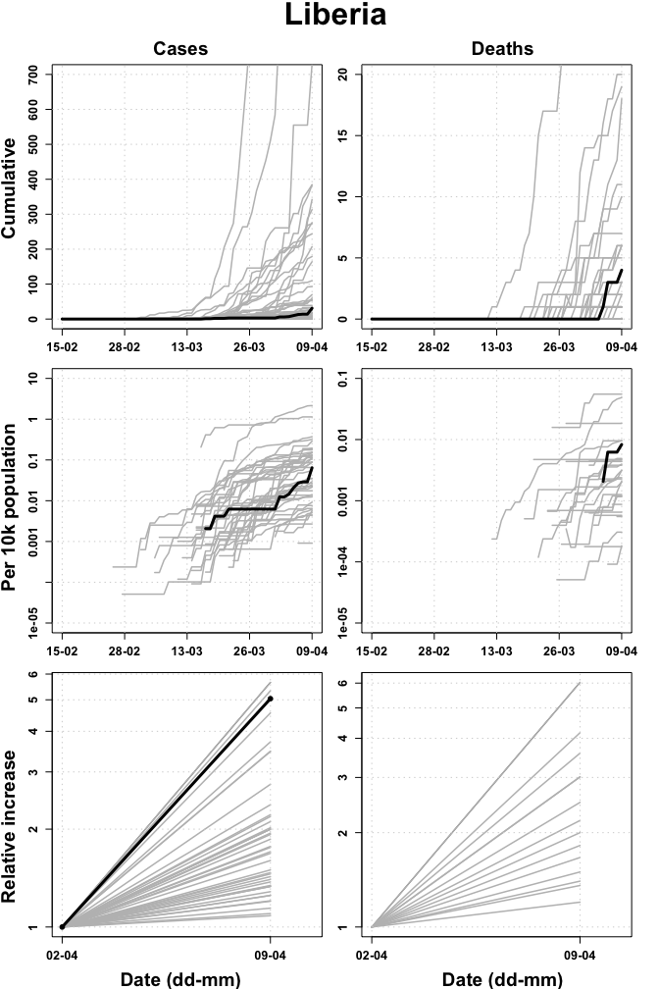

## Madagascar

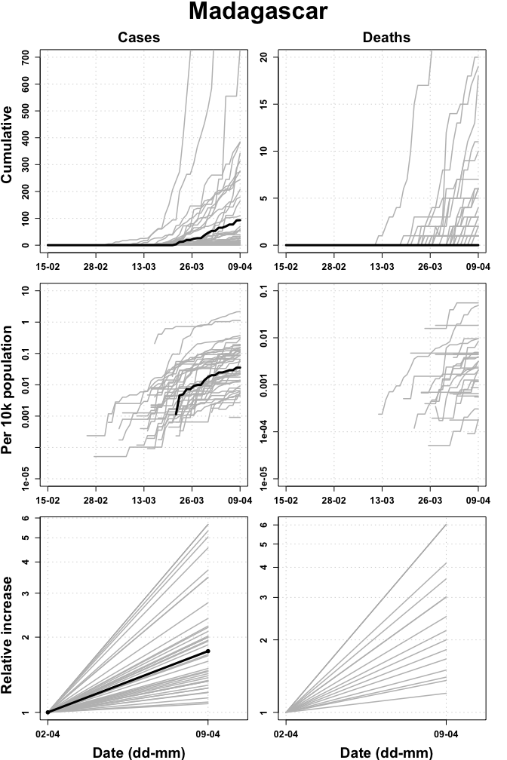

## Malawi

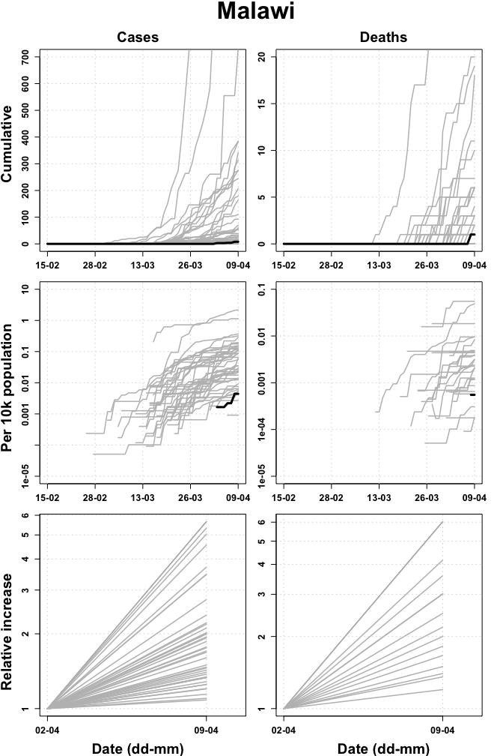

## Mali

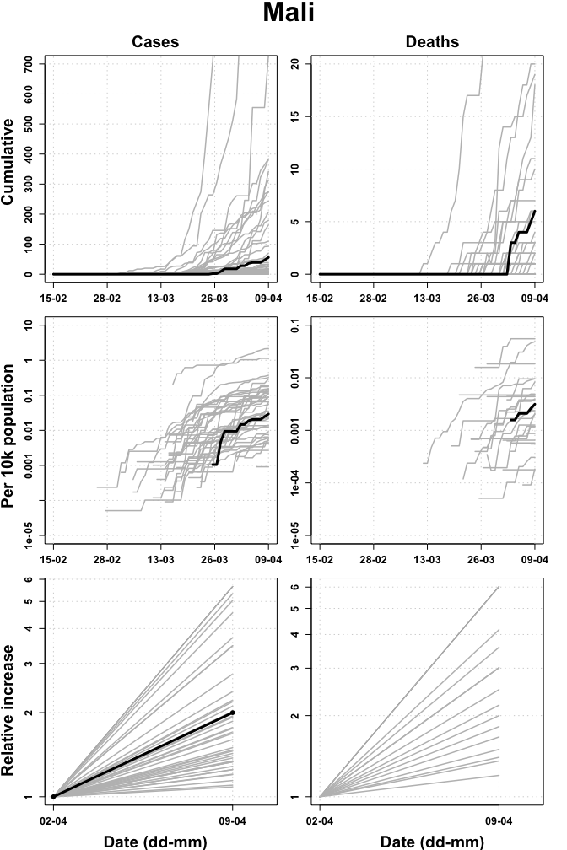

## Mauritania

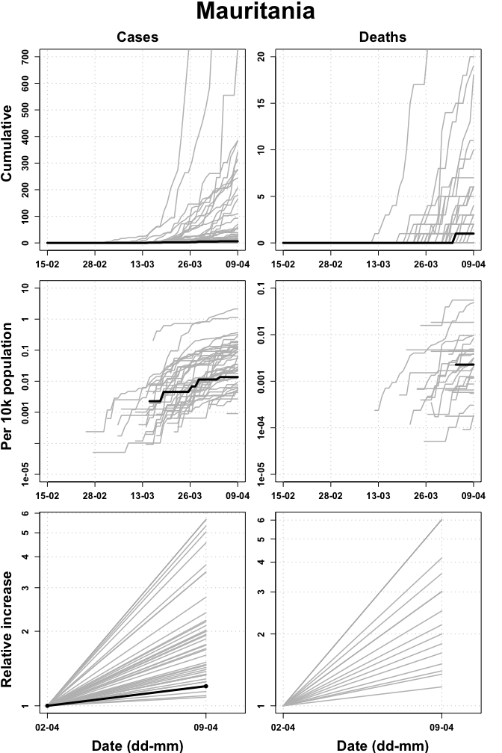

## Mauritius

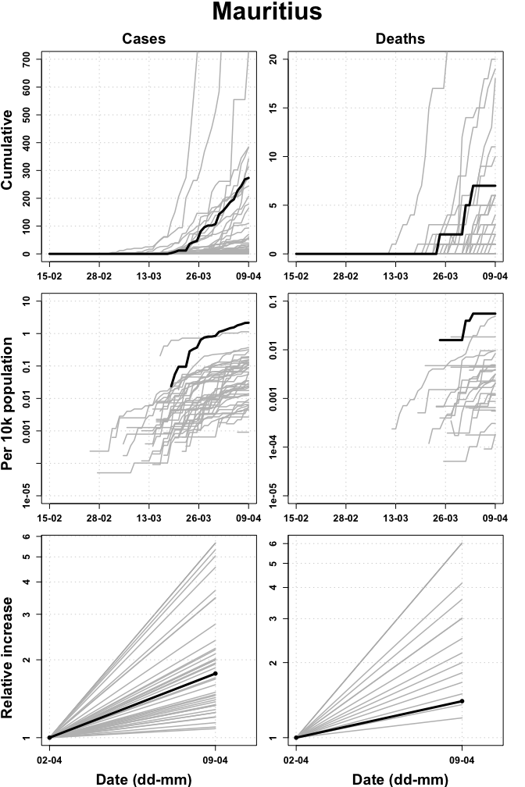

## Mozambique

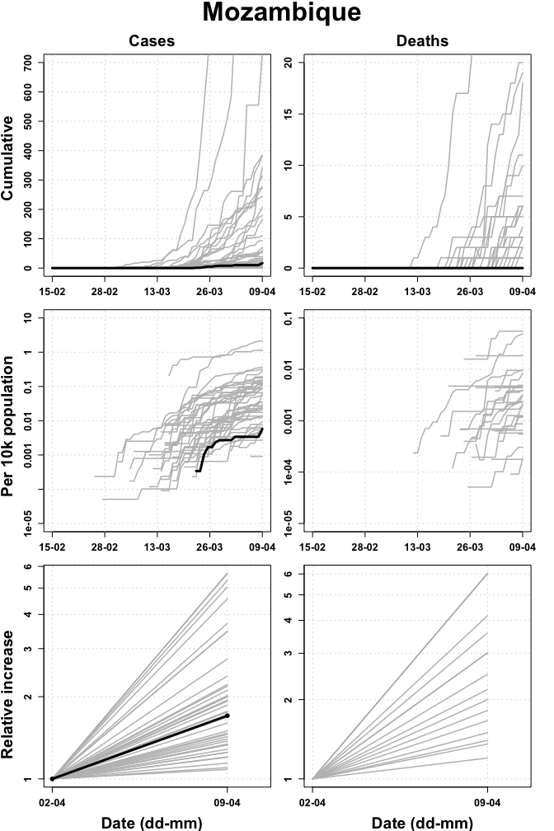

## Namibia

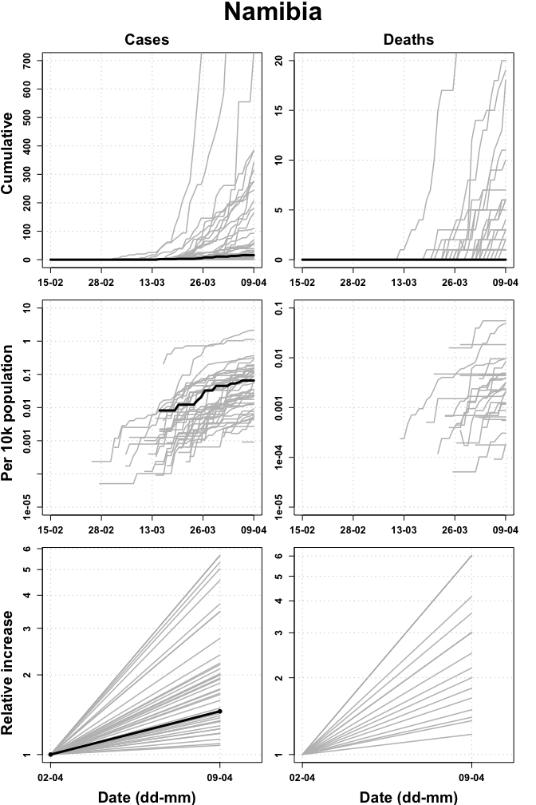

## Niger

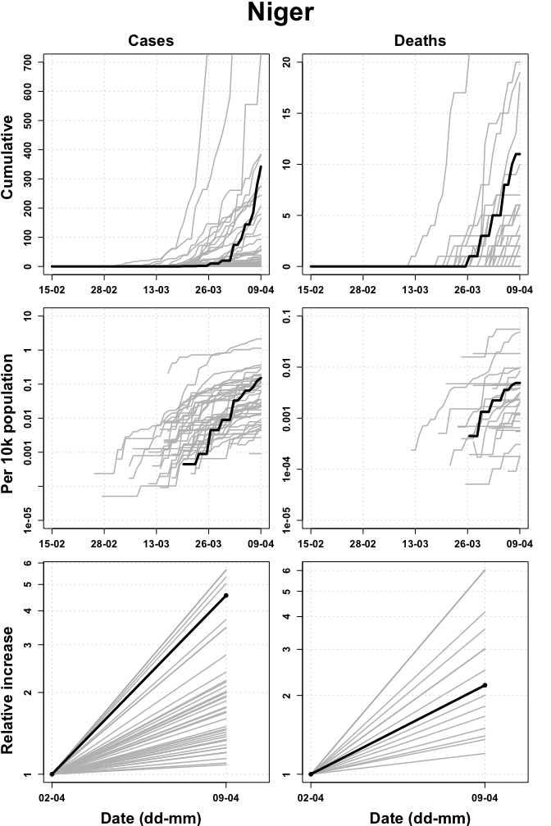

## Nigeria

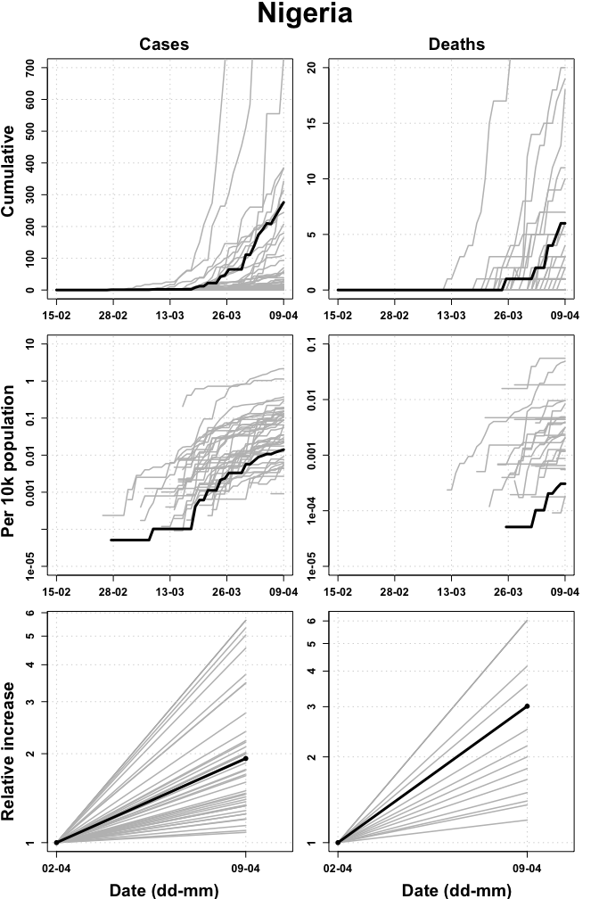

## Rwanda

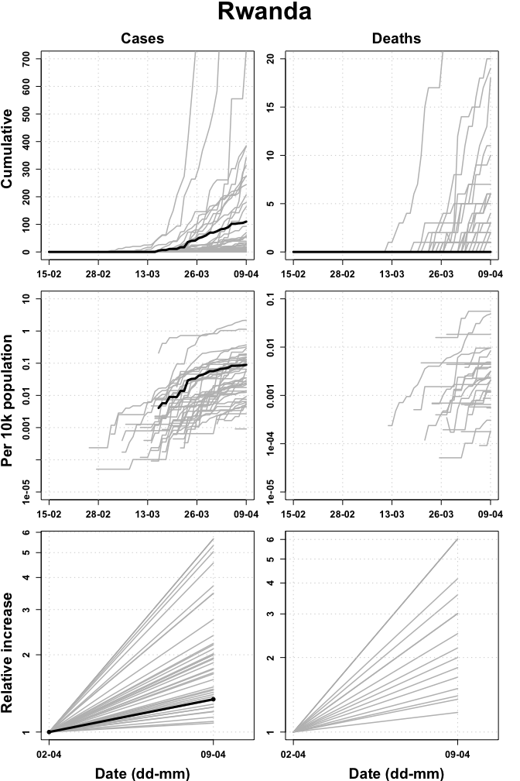

## Sao Tome and Principe

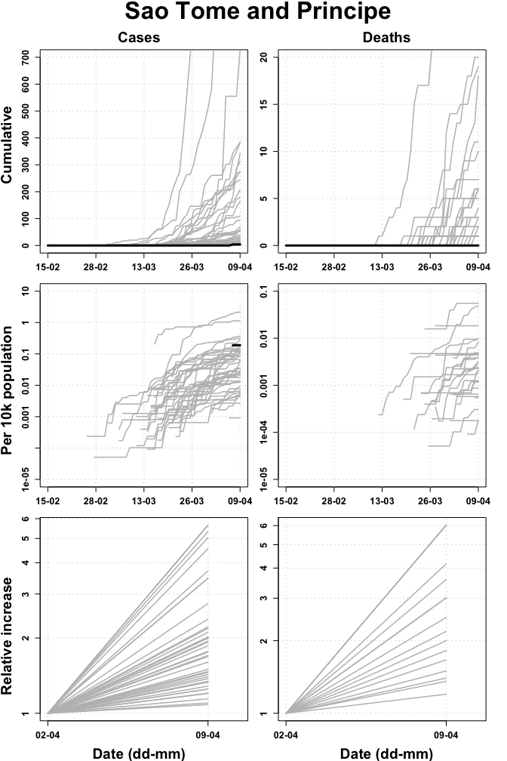

## Senegal

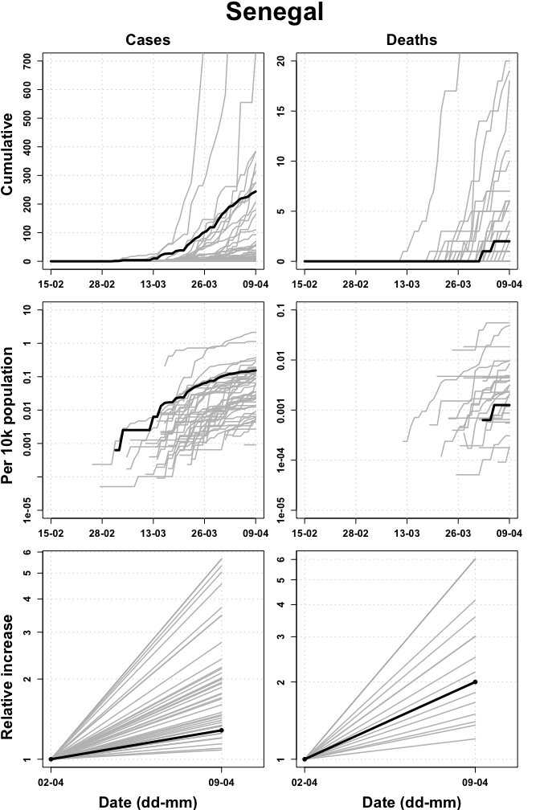

## Seychelles

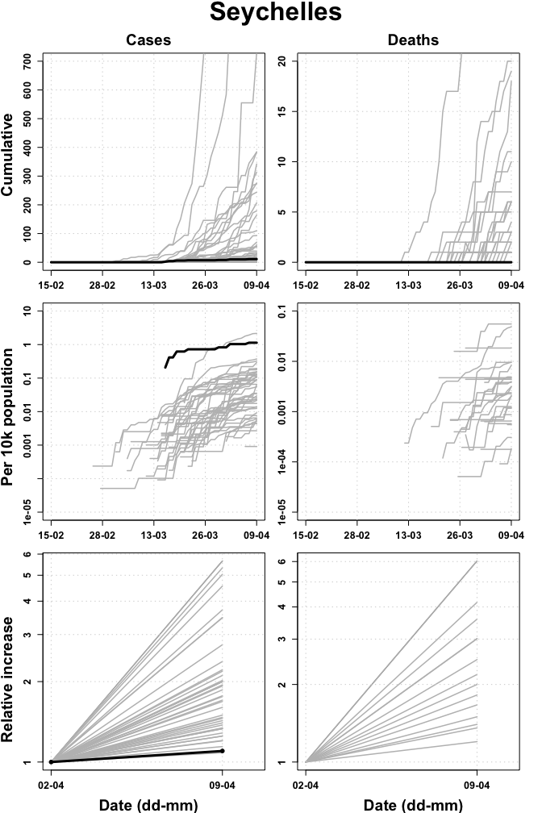

## Sierra Leone

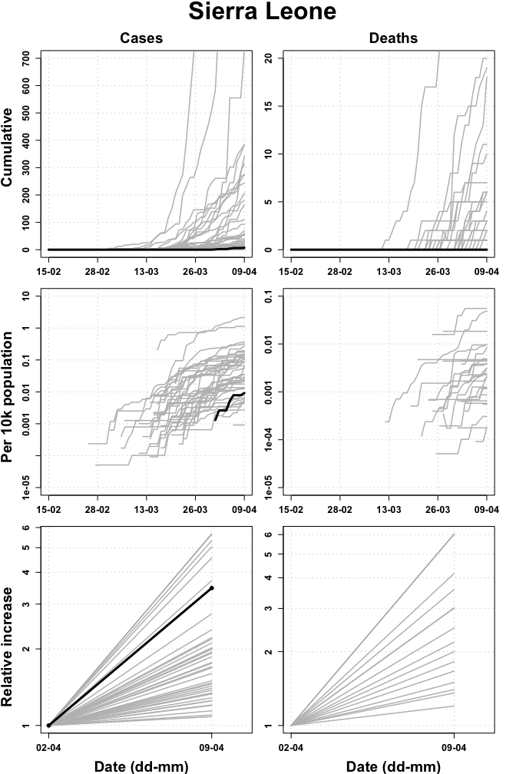

## South Africa

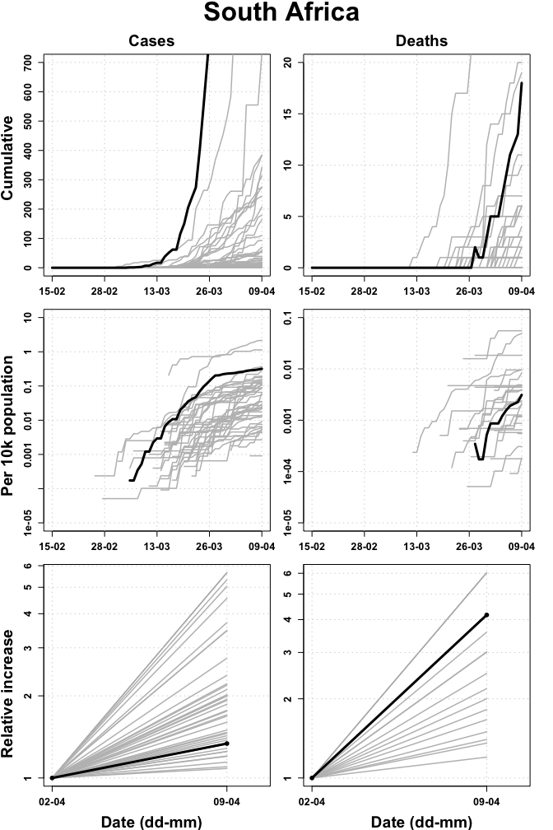

## South Sudan

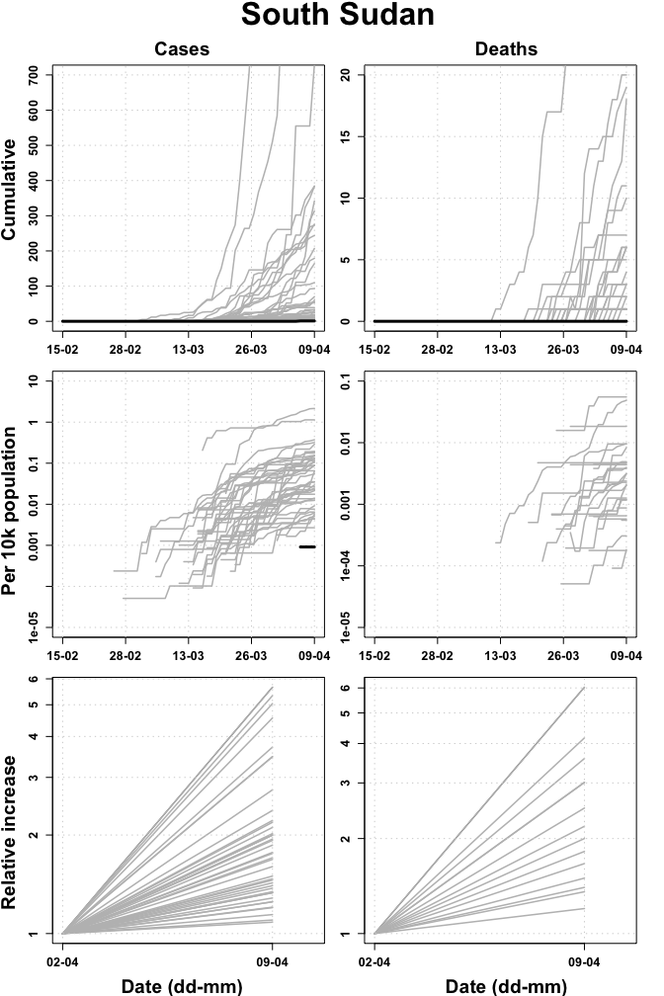

## Togo

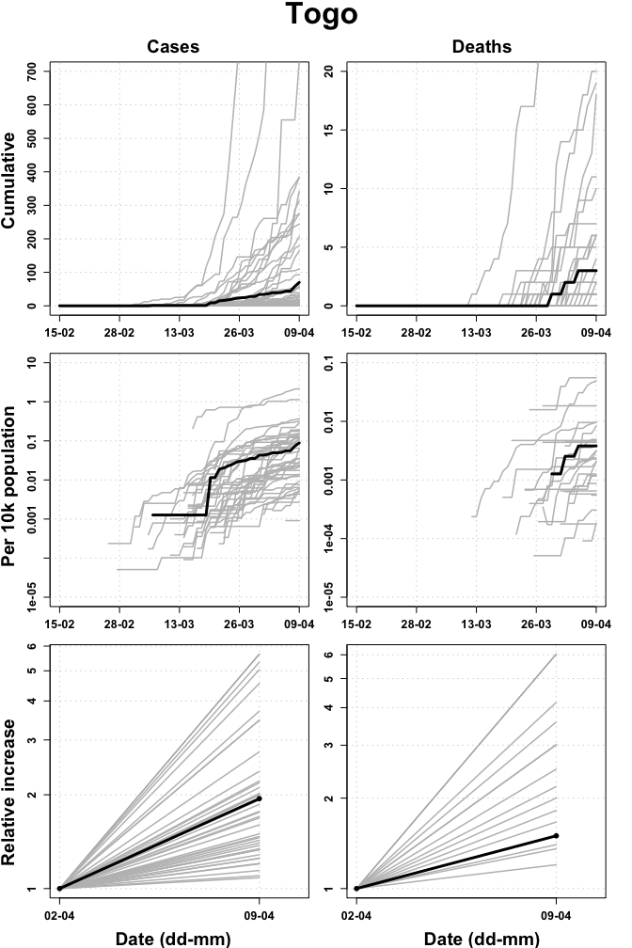

## Uganda

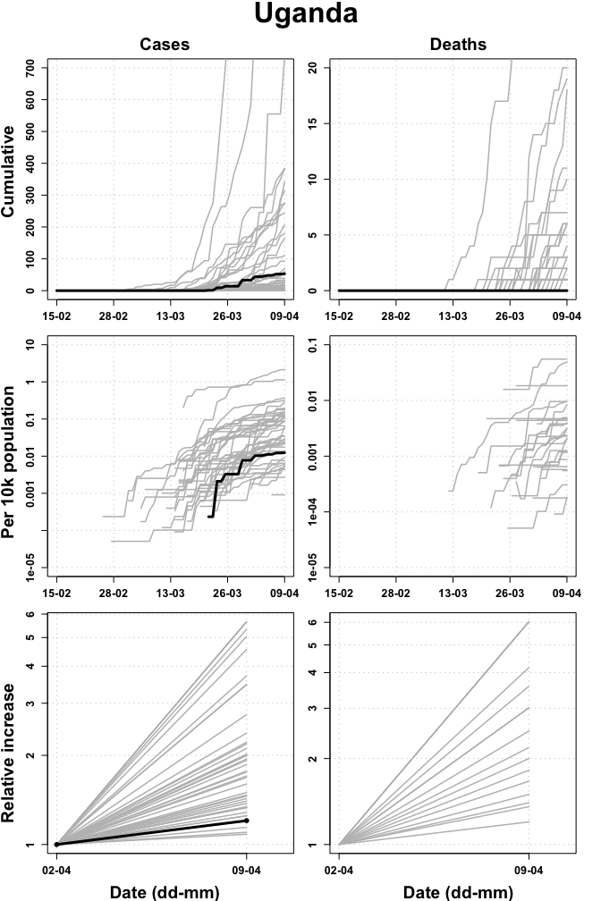

## United Republic of Tanzania

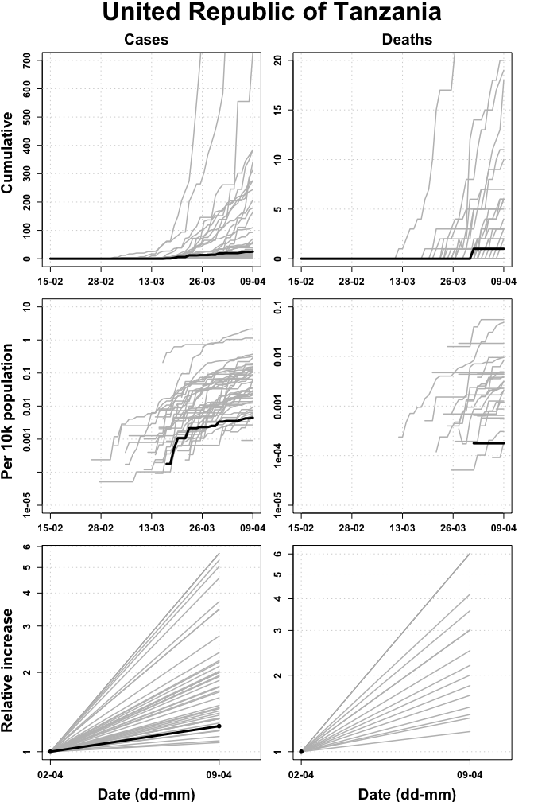

## Zambia

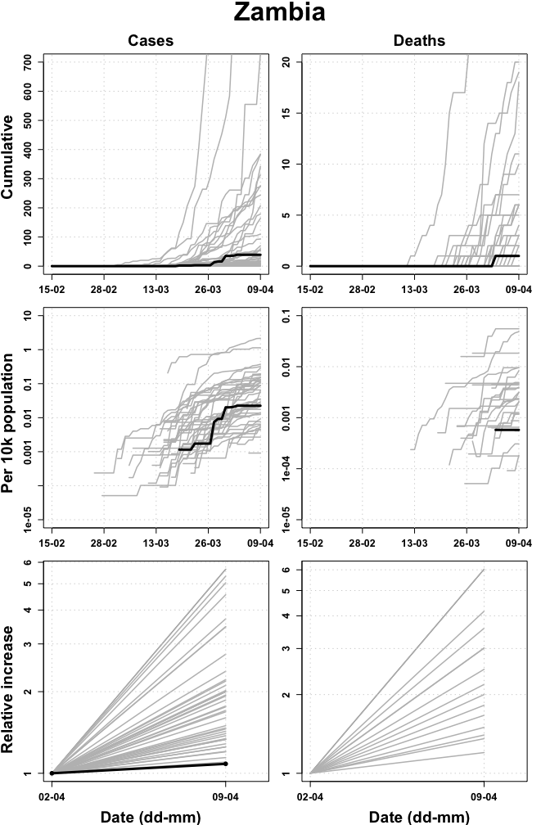

## Zimbabwe

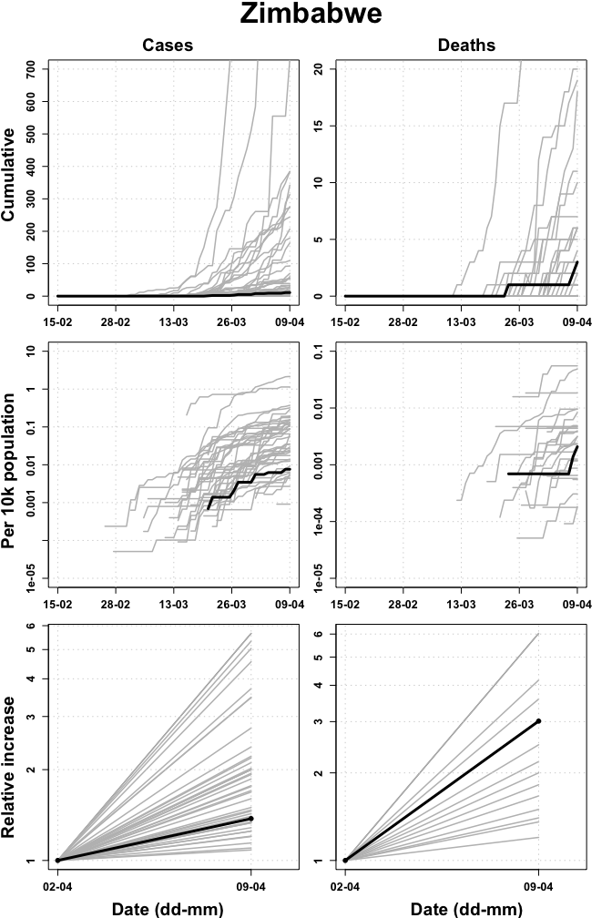

# Appendix

## Data

### Sources and access

* Case counts for countries in WHO Africa Region from WHO Coronavirus disease (COVID-2019) situation reports <https://www.who.int/emergencies/diseases/novel-coronavirus-2019/situation-reports> (accessed 2400 09/04/2020).
* Death counts for countries in WHO African Region from WHO Coronavirus disease (COVID-2019) situation reports <https://www.who.int/emergencies/diseases/novel-coronavirus-2019/situation-reports> (accessed 2400 09/04/2020).
* Population counts from the World Bank (2018) <https://data.worldbank.org/indicator/SP.POP.TOTL?locations=ZG> (accessed 0900 30/03/2020).

### Doubling time calculations

Calculated over prior 7 days using method described by *E. Vynnycky & R. White (2010) An Introduction to Infectious Disease Modelling*, page 74.

Confidence intervals calculated using bootstrapping of a simulated dataset with Poisson error structure, using method published here: <https://doi.org/10.1101/2020.02.05.20020750>.

### Caveats

* Case count data are affected by any changes in testing strategy or testing effort over time and/or any variation in testing strategy or testing effort between regions.
* Case count data are likely a substantial under-representation of the true number of COVID-19 infections.
* Death data are considered more reliable but may lag behind case data by as much as 3 weeks.
* Data are provided by WHO Afro but were smoothed where necessary (e.g. if a decrease in cumulative count was reported) for doubling time calculations.

## Extended data tables

### Cumulative reported cases

|  |  |  |  |
| --- | --- | --- | --- |
| Country | Cum. reported cases | 95%CI lower | 95%CI upper |
| South Africa | 1845 | 1779 | 1916 |
| Algeria | 1572 | 1506 | 1642 |
| Cameroon | 716 | 671 | 762 |
| Burkina Faso | 384 | 352 | 414 |
| Cote d’Ivoire | 384 | 353 | 417 |
| Niger | 342 | 313 | 374 |
| Ghana | 313 | 282 | 343 |
| Mauritius | 273 | 246 | 303 |
| Nigeria | 267 | 241 | 295 |
| Senegal | 244 | 219 | 269 |
| Democratic Republic of the Congo | 207 | 184 | 231 |
| Kenya | 179 | 156 | 201 |
| Guinea | 164 | 143 | 184 |
| Rwanda | 110 | 94 | 129 |
| Madagascar | 93 | 77 | 109 |
| Togo | 70 | 57 | 84 |
| Congo | 60 | 47 | 73 |
| Mali | 56 | 45 | 69 |
| Ethiopia | 55 | 44 | 68 |
| Uganda | 53 | 41 | 65 |
| Zambia | 39 | 30 | 49 |
| Eritrea | 33 | 24 | 43 |
| Guinea Bissau | 33 | 24 | 42 |
| Liberia | 31 | 22 | 40 |
| Benin | 26 | 18 | 35 |
| United Republic of Tanzania | 25 | 17 | 34 |
| Gabon | 24 | 17 | 32 |
| Angola | 19 | 12 | 26 |
| Mozambique | 17 | 10 | 24 |
| Equatorial Guinea | 16 | 10 | 23 |
| Namibia | 16 | 9 | 23 |
| Eswatini | 12 | 7 | 18 |
| Zimbabwe | 11 | 6 | 17 |
| Seychelles | 11 | 6 | 17 |
| Central African Republic | 10 | 5 | 16 |
| Chad | 10 | 5 | 15 |
| Malawi | 8 | 4 | 13 |
| Cabo Verde | 7 | 3 | 12 |
| Sierra Leone | 7 | 3 | 11 |
| Botswana | 6 | 2 | 10 |
| Mauritania | 6 | 2 | 10 |
| Gambia | 4 | 1 | 7 |
| Sao Tome and Principe | 4 | 1 | 7 |
| Burundi | 3 | 0 | 6 |
| South Sudan | 1 | 0 | 3 |
| Comoros | 0 | NA | NA |
| Lesotho | 0 | NA | NA |

### Cumulative reported cases per 10,000 population

|  |  |  |  |
| --- | --- | --- | --- |
| Country | Cum. reported cases per 10k pop. | 95%CI lower | 95%CI upper |
| Mauritius | 2.1576 | 1.9442 | 2.3947 |
| Seychelles | 1.1368 | 0.6201 | 1.7569 |
| Algeria | 0.3723 | 0.3566 | 0.3888 |
| South Africa | 0.3193 | 0.3079 | 0.3316 |
| Cameroon | 0.2839 | 0.2661 | 0.3022 |
| Burkina Faso | 0.1944 | 0.1782 | 0.2096 |
| Sao Tome and Principe | 0.1895 | 0.0474 | 0.3317 |
| Guinea Bissau | 0.1761 | 0.1280 | 0.2241 |
| Senegal | 0.1539 | 0.1381 | 0.1697 |
| Cote d’Ivoire | 0.1532 | 0.1408 | 0.1663 |
| Niger | 0.1524 | 0.1395 | 0.1666 |
| Guinea | 0.1321 | 0.1152 | 0.1483 |
| Cabo Verde | 0.1287 | 0.0552 | 0.2207 |
| Equatorial Guinea | 0.1222 | 0.0764 | 0.1757 |
| Congo | 0.1144 | 0.0896 | 0.1392 |
| Gabon | 0.1132 | 0.0802 | 0.1510 |
| Ghana | 0.1051 | 0.0947 | 0.1152 |
| Rwanda | 0.0894 | 0.0764 | 0.1049 |
| Togo | 0.0887 | 0.0723 | 0.1065 |
| Eswatini | 0.0878 | 0.0512 | 0.1317 |
| Namibia | 0.0654 | 0.0368 | 0.0939 |
| Liberia | 0.0643 | 0.0457 | 0.0831 |
| Eritrea | 0.0545 | 0.0397 | 0.0711 |
| Madagascar | 0.0354 | 0.0293 | 0.0415 |
| Kenya | 0.0348 | 0.0304 | 0.0391 |
| Mali | 0.0294 | 0.0236 | 0.0362 |
| Botswana | 0.0266 | 0.0089 | 0.0444 |
| Democratic Republic of the Congo | 0.0246 | 0.0219 | 0.0275 |
| Benin | 0.0226 | 0.0157 | 0.0305 |
| Zambia | 0.0225 | 0.0173 | 0.0282 |
| Central African Republic | 0.0214 | 0.0107 | 0.0343 |
| Gambia | 0.0175 | 0.0044 | 0.0307 |
| Nigeria | 0.0136 | 0.0123 | 0.0151 |
| Mauritania | 0.0136 | 0.0045 | 0.0227 |
| Uganda | 0.0124 | 0.0096 | 0.0152 |
| Sierra Leone | 0.0092 | 0.0039 | 0.0144 |
| Zimbabwe | 0.0076 | 0.0042 | 0.0118 |
| Chad | 0.0065 | 0.0032 | 0.0097 |
| Angola | 0.0062 | 0.0039 | 0.0084 |
| Mozambique | 0.0058 | 0.0034 | 0.0081 |
| Ethiopia | 0.0050 | 0.0040 | 0.0062 |
| United Republic of Tanzania | 0.0044 | 0.0030 | 0.0060 |
| Malawi | 0.0044 | 0.0022 | 0.0072 |
| Burundi | 0.0027 | 0.0000 | 0.0054 |
| South Sudan | 0.0009 | 0.0000 | 0.0027 |
| Comoros | 0 | NA | NA |
| Lesotho | 0 | NA | NA |

### Cumulative deaths

|  |  |
| --- | --- |
| Country | Cum. reported deaths |
| Algeria | 205 |
| Democratic Republic of the Congo | 20 |
| Burkina Faso | 19 |
| South Africa | 18 |
| Niger | 11 |
| Cameroon | 10 |
| Mauritius | 7 |
| Ghana | 6 |
| Kenya | 6 |
| Mali | 6 |
| Nigeria | 6 |
| Congo | 5 |
| Liberia | 4 |
| Cote d’Ivoire | 3 |
| Togo | 3 |
| Zimbabwe | 3 |
| Angola | 2 |
| Ethiopia | 2 |
| Senegal | 2 |
| Benin | 1 |
| Botswana | 1 |
| Cabo Verde | 1 |
| Gabon | 1 |
| Gambia | 1 |
| Malawi | 1 |
| Mauritania | 1 |
| United Republic of Tanzania | 1 |
| Zambia | 1 |
| Burundi | 0 |
| Central African Republic | 0 |
| Chad | 0 |
| Comoros | 0 |
| Equatorial Guinea | 0 |
| Eritrea | 0 |
| Eswatini | 0 |
| Guinea | 0 |
| Guinea-Bissau | 0 |
| Lesotho | 0 |
| Madagascar | 0 |
| Mozambique | 0 |
| Namibia | 0 |
| Rwanda | 0 |
| Sao Tome and Principe | 0 |
| Seychelles | 0 |
| Sierra Leone | 0 |
| South Sudan | 0 |
| Uganda | 0 |

### Cumulative deaths per 10,000 populations

|  |  |
| --- | --- |
| Country | Cum. reported deaths per 10k pop. |
| Mauritius | 0.0553 |
| Algeria | 0.0485 |
| Cabo Verde | 0.0184 |
| Burkina Faso | 0.0096 |
| Congo | 0.0095 |
| Liberia | 0.0083 |
| Niger | 0.0049 |
| Gabon | 0.0047 |
| Botswana | 0.0044 |
| Gambia | 0.0044 |
| Cameroon | 0.0040 |
| Togo | 0.0038 |
| Mali | 0.0031 |
| South Africa | 0.0031 |
| Democratic Republic of the Congo | 0.0024 |
| Mauritania | 0.0023 |
| Zimbabwe | 0.0021 |
| Ghana | 0.0020 |
| Senegal | 0.0013 |
| Cote d’Ivoire | 0.0012 |
| Kenya | 0.0012 |
| Benin | 0.0009 |
| Angola | 0.0006 |
| Zambia | 0.0006 |
| Malawi | 0.0006 |
| Nigeria | 0.0003 |
| Ethiopia | 0.0002 |
| United Republic of Tanzania | 0.0002 |
| Burundi | 0.0000 |
| Central African Republic | 0.0000 |
| Chad | 0.0000 |
| Comoros | 0.0000 |
| Equatorial Guinea | 0.0000 |
| Eritrea | 0.0000 |
| Eswatini | 0.0000 |
| Guinea | 0.0000 |
| Guinea-Bissau | 0.0000 |
| Lesotho | 0.0000 |
| Madagascar | 0.0000 |
| Mozambique | 0.0000 |
| Namibia | 0.0000 |
| Rwanda | 0.0000 |
| Sao Tome and Principe | 0.0000 |
| Seychelles | 0.0000 |
| Sierra Leone | 0.0000 |
| South Sudan | 0.0000 |
| Uganda | 0.0000 |

### Doubling time (cases)

|  |  |  |  |
| --- | --- | --- | --- |
| Country | Doubling time (days) | 95%CI lower | 95%CI upper |
| Cameroon | 2.8 | 2.6 | 3.0 |
| Guinea | 2.9 | 2.4 | 3.3 |
| Liberia | 3.0 | 2.0 | 4.3 |
| Niger | 3.2 | 2.8 | 3.5 |
| Guinea-Bissau | 3.7 | 2.5 | 5.3 |
| Gabon | 3.9 | 2.5 | 6.1 |
| Sierra Leone | 3.9 | 2.3 | 10.3 |
| Congo | 4.8 | 3.6 | 6.6 |
| Angola | 5.6 | 3.4 | 10.3 |
| Kenya | 6.1 | 5.2 | 7.3 |
| Eritrea | 6.2 | 4.2 | 9.3 |
| Ethiopia | 6.5 | 4.7 | 9.1 |
| Cote d’Ivoire | 6.9 | 6.1 | 7.8 |
| Benin | 7.0 | 4.4 | 12.0 |
| Botswana | 7.0 | 3.0 | 41.2 |
| Mali | 7.0 | 5.1 | 9.8 |
| Togo | 7.3 | 5.4 | 9.9 |
| Nigeria | 7.4 | 6.4 | 8.6 |
| Algeria | 7.8 | 7.4 | 8.4 |
| Mauritius | 8.5 | 7.3 | 9.9 |
| Madagascar | 8.6 | 6.8 | 11.4 |
| Mozambique | 9.1 | 5.1 | 21.7 |
| Democratic Republic of the Congo | 9.3 | 7.9 | 11.4 |
| Ghana | 10.3 | 8.8 | 12.0 |
| Burundi | 12.0 | 4.4 | Inf |
| Burkina Faso | 12.6 | 10.9 | 14.8 |
| Namibia | 12.9 | 7.0 | 38.9 |
| Chad | 13.6 | 5.3 | Inf |
| Cabo Verde | 14.4 | 5.3 | Inf |
| Zimbabwe | 15.2 | 7.0 | Inf |
| Rwanda | 16.5 | 12.3 | 23.9 |
| South Africa | 16.7 | 15.5 | 18.1 |
| Eswatini | 16.9 | 7.7 | 80.5 |
| Gambia | 16.9 | 4.4 | Inf |
| Senegal | 19.4 | 15.7 | 24.6 |
| Central African Republic | 21.7 | 9.0 | Inf |
| United Republic of Tanzania | 21.7 | 12.0 | 65.5 |
| Uganda | 26.1 | 16.5 | 55.8 |
| Mauritania | 26.6 | 7.0 | Inf |
| Equatorial Guinea | 36.3 | 14.9 | Inf |
| Seychelles | 50.9 | 16.9 | Inf |
| Zambia | 60.6 | 28.6 | 220.8 |
| Comoros | NA | NA | NA |
| Lesotho | NA | NA | NA |
| Malawi | NA | NA | NA |
| Sao Tome and Principe | NA | NA | NA |
| South Sudan | NA | NA | NA |

### Doubling time (deaths)

|  |  |  |  |
| --- | --- | --- | --- |
| Country | Doubling time (days) | 95%CI lower | 95%CI upper |
| Kenya | 2.7 | 2.2 | 7.0 |
| South Africa | 3.4 | 2.0 | 5.7 |
| Algeria | 3.8 | 3.3 | 4.4 |
| Nigeria | 4.4 | 2.5 | 14.0 |
| Zimbabwe | 4.4 | 3.0 | Inf |
| Congo | 5.3 | 2.7 | 16.9 |
| Niger | 6.2 | 3.1 | 14.4 |
| Senegal | 7.0 | 4.4 | Inf |
| Democratic Republic of the Congo | 8.1 | 4.8 | 15.6 |
| Cameroon | 9.5 | 4.4 | 29.4 |
| Togo | 12.0 | 4.4 | Inf |
| Mauritius | 14.4 | 5.3 | Inf |
| Burkina Faso | 15.9 | 8.4 | 46.1 |
| Ghana | 26.6 | 8.3 | Inf |
| Angola | Inf | Inf | Inf |
| Botswana | Inf | Inf | Inf |
| Cabo Verde | Inf | Inf | Inf |
| Gabon | Inf | Inf | Inf |
| Gambia | Inf | Inf | Inf |
| United Republic of Tanzania | Inf | Inf | Inf |
| Benin | NA | NA | NA |
| Burundi | NA | NA | NA |
| Central African Republic | NA | NA | NA |
| Chad | NA | NA | NA |
| Comoros | NA | NA | NA |
| Cote d’Ivoire | NA | NA | NA |
| Equatorial Guinea | NA | NA | NA |
| Eritrea | NA | NA | NA |
| Eswatini | NA | NA | NA |
| Ethiopia | NA | NA | NA |
| Guinea | NA | NA | NA |
| Guinea-Bissau | NA | NA | NA |
| Lesotho | NA | NA | NA |
| Liberia | NA | NA | NA |
| Madagascar | NA | NA | NA |
| Malawi | NA | NA | NA |
| Mali | NA | NA | NA |
| Mauritania | NA | NA | NA |
| Mozambique | NA | NA | NA |
| Namibia | NA | NA | NA |
| Rwanda | NA | NA | NA |
| Sao Tome and Principe | NA | NA | NA |
| Seychelles | NA | NA | NA |
| Sierra Leone | NA | NA | NA |
| South Sudan | NA | NA | NA |
| Uganda | NA | NA | NA |
| Zambia | NA | NA | NA |